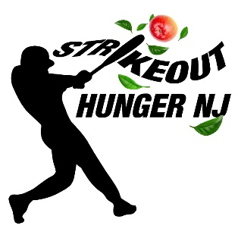

One Historic Day.  One Tournament. | Saturday, May 2, 2020  Rain date Sunday, May 3, 2020
One Mission: “Send HUNGER to the bench.” | Riegel Ridge Community Center  Holland Township, NJ
Team (Check one) | √
Milford
Frenchtown
Alexandria
Holland
Phillipsburg
ShopRite

Name
Street Address

City, State, Zip
Email Address
Phone Number
Emergency Contact

I understand and have signed the Indemnification Agreement attached.

_________________________________________________ __________________________
Signature Date

